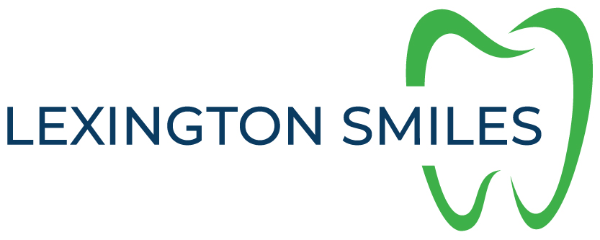

Lex Smile Dental Plan

Includes all exams, two cleanings, fluoride treatments, all imaging AND 20% off any additional services

Adult 13 plus: $400.00
Children 12 and under: $300.00
Children 5 and under: $150.00

